Circuit 2

* Part 1

Programmable logic block to configure it as a ‘NAND’ or a ‘NOR’ gate using a single selection bit

First I drew a truth table for this part considering a single selection bit (S) with two inputs (A, B) such that S=0 for ‘NAND’ and S=1 for ‘NOR’ operations respectively.

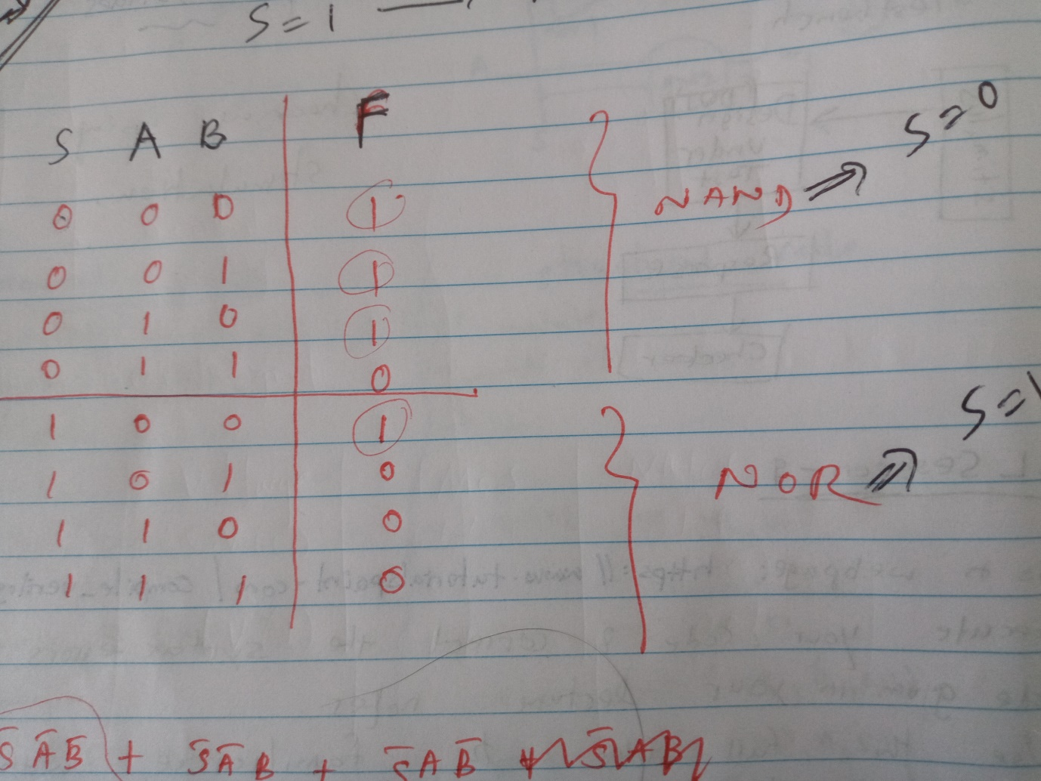

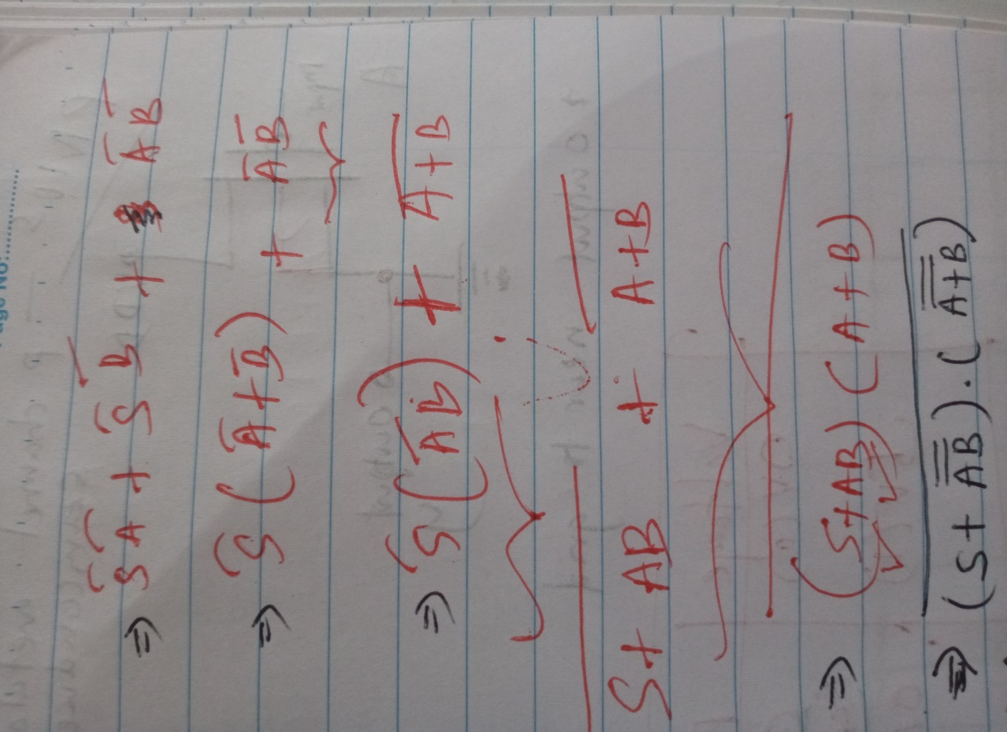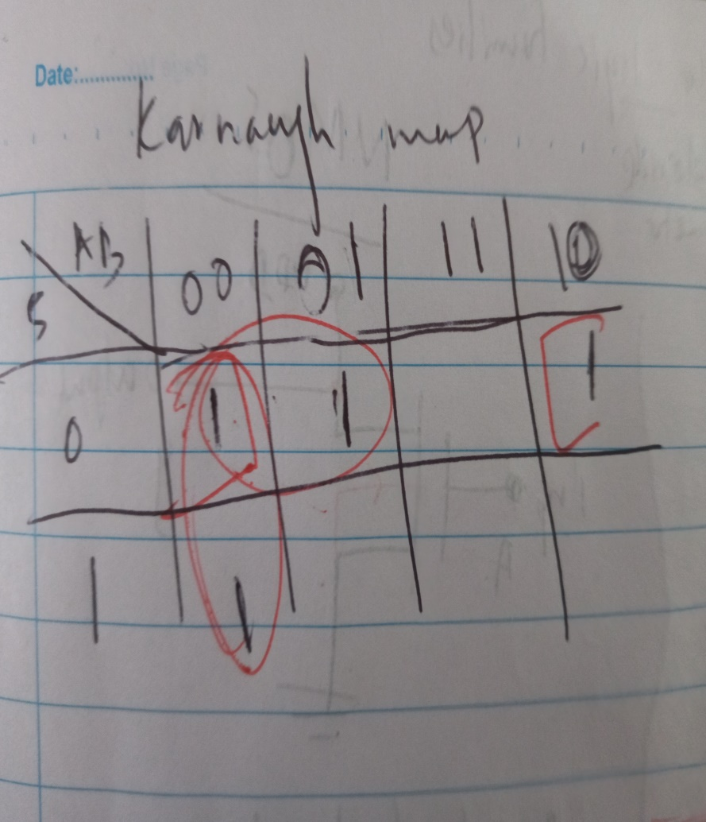Then the relevant logic expression was obtained using a karnaugh map and it was further simplified to obtain the combination of 'NAND' and 'NOR' operations.

So, the resultant combinational logic circuit is as follows. (2 NANDs, 2 NORs, 3 NOTs)

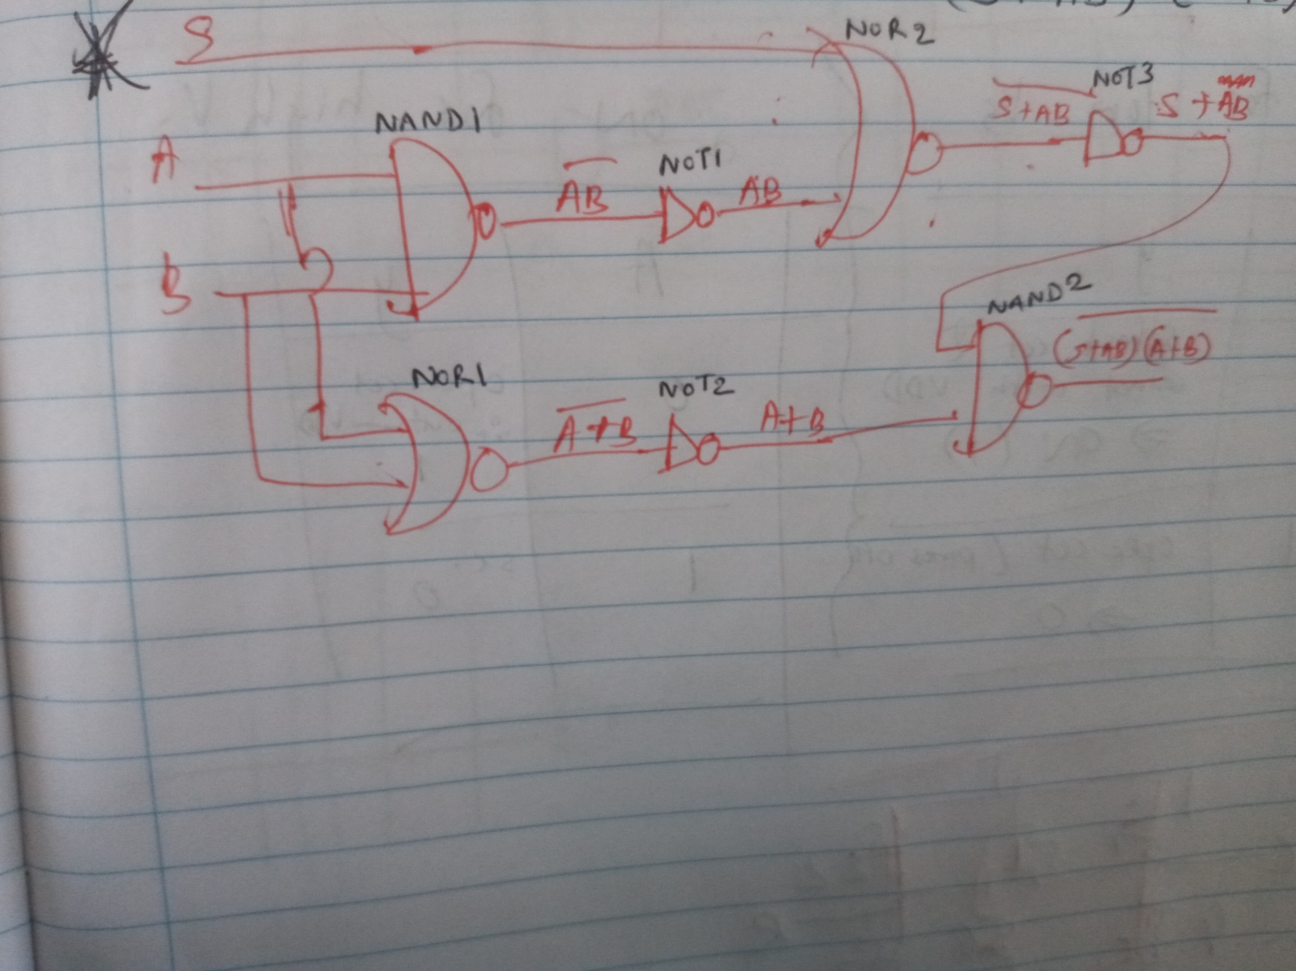

For the implementation of this circuit; ‘NOT’, ‘NAND’, and 'NOR' gates were designed using 'NMOS' and 'PMOS' transistors. Their schematics in LTspice are depicted below.

**Pdfs- 2part1**

**NOT** – Figure- Schematic of NOT gate

**NAND** – Figure- Schematic of NAND gate

**NOR** – Figure- Schematic of NOR gate

Finally, the PLD block is designed using the above gates and the waveforms were obtained.

**cct**- Figure- Circuit designed using logic blocks

**block**- Figure- Designed PLD block

**wave**- Figure- Waveforms for inputs and output of PLD